**TASK REPORT**

**DATA SCIENCE AND ITS IMPLEMENTATION IN**

**CODING**



**By:**

**Mohamad Irwan Afandi**

**Data Science Student**

**Data Fellowship**

**2020**

**Chapter 1**

**Introduction**

Coding is one of the fundamentals that mast be mastered (at least know) by a data science. Why the data science need coding? The answer is, there are several task that we have to do like communication to server, get data from database, make data analysis, build a machine learning model, create an algorithm to solve problems, and soon. If we don’t know about code, could we to be a professional data science? Think about it, so code is a must. As a beginner, we often ask “From the existing programming language, what must we learn for basic data science?” We can answer it by looking at the data science task. We know that the data science often work with database, algorithm and server. So the answer is SQL (for data base), Python (algorithm and build machine learning model) and the last is linux command + shell scripting (communicate with the server). Based on that problems, this report will show you some of real cases and how to solve it using code. But for the next time you need to explore it by yourself, at least you know what the code looks like. One think that you need to remember about coding, “***You don’t need to memorize every lines of code but you need to practice as often as possible, after that the miracle will show you how easy it is. Keep learning guys!***”

**Chapter 2**

**Progress Report**

In this chapter you will have to fill in the table below according to the progress of the project that you have made along the way. We need to know how long it takes for you and how big the effort that you have done in order to complete this task. We appreciate detailed information.

|  |  |  |  |
| --- | --- | --- | --- |
| **Day/Date** | **Task** | **Level** (easy/medium/hard) | **Comments** |
| 11/08/2020 | Doing all quizzes in iykra’s website | easy | Takes a lot of time because too much subject need to learn |
| 12/08/2020 | Load and restore the dvd rental data into DBeaver, Solve the query problems | medium | Confused how to restore the data at the first time, takes time to understand the question and erd |
| 13/08/2020 | Python (create a function) and upload it into github. | Easy | Need more effort to design the read.me to make a better documentation on github. |
| 14/08/2020 | Create Summary and video for DB and Python, write in medium (how to install anaconda) | medium | New tools, write in medium :v |
| 15/08/2020 | Shell scripting, Create summary and video for shell scripting, write in github (basic linux command) | medium | Never learn linux command before, but it’s fun |
| 16/08/2020 | Creating coding practice case report | easy | Feel so tired ☺ |

**Chapter 3**

**Task Report**

1. Please make SQL queries to answer these questions and post them on your Github account!

**Answer:**

The data used in this case study is DVD rental that can be downloaded on Postgresql website, or just access the link below.

[*https://www.postgresqltutorial.com/postgresql-sample-database/*](https://www.postgresqltutorial.com/postgresql-sample-database/)

The first, you need to understand the ER Model of the database to know the relations between tables. The following is the ER Model for the DVD rental Database.

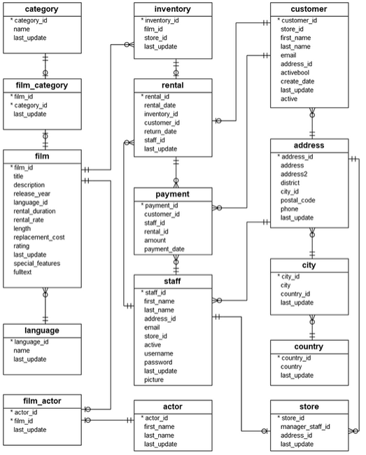

Furthermore, to answer the question we need to understand DML (Data Manipulation Language) syntax especially “select”. In select syntax you also need to understand about where condition, aggregation function, grouping, having and ordering. The pattern from the select syntax can be seen below.

**select** col_name, aggregarion_function(col_name)

**from** tb_a join tb_b on tb_a.id = tb_b.a_id

**where** column_condition

**group by** col_name

**having** aggregation condition

**order by** col_name;

Now, we are ready to solve our task.

**Question 1**

A customer wants to know the films about “astronaut”. How many recommendations could you give for him?

The purpose of this question is we need to count the number of films that the genre (from fulltext column) is astronaut. So we can find the data on film table with count of id_film as the aggregation function. The picture below shows the result of this question.

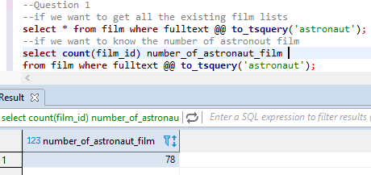

So the answer is, there are 78 films about Astronaut

**Question 2**

How many films have a rating of “R” and a replacement cost between $5 and 15?

The purpose of this question is we need to count the number of films which have “R” rating with condition the replacement cost between 5 and 15 (2 condition using and) where we can get the data from table film. The picture below shows the result of this question.

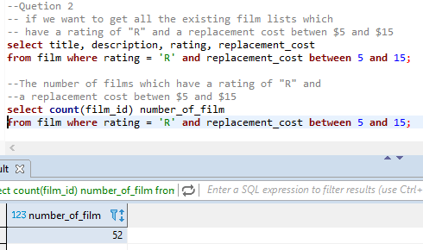

So the answer is, there are 52 films which have R rating and replacement cost between $5 and $15.

**Question 3**

We have two staff members with staff IDs 1 and 2. We want to give a bonus to the staff member that handled the most payments. How many payments did each staff member handle? And how much was the total amount processed by each staff member?

The purpose of this question is we need to calculate the payment transaction and the sum amount of that transaction group by staff id, and then short it descending. We can get this data from table payment join with table staff. The picture below shows the result of this question.

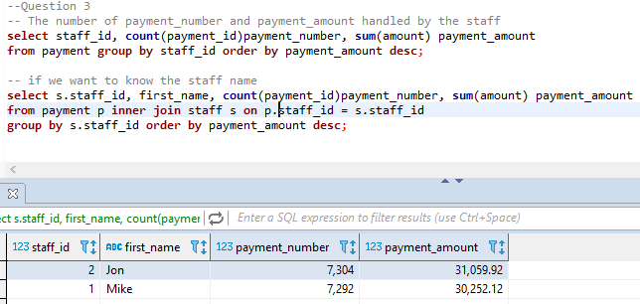

So we give the bonus to Jhon who can handle payment with the total amount $31.059,92

**Question 4**

Corporate headquarters is auditing the store, they want to know the average replacement cost of movies by rating.

The purpose of this question is we need to calculate the average replacement cost of movies group by rating and order the average ascending to make it easier to read. We can get the data from table film. The picture below shows the result of this question.

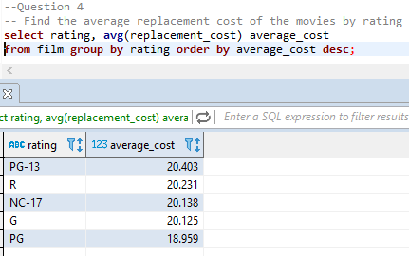

**Question 5**

We want to send coupons to the 5 customers who have spent the most amount of money. Get the customer name, email and their spent amount!

The purpose of this question is we need to get customer’s name, email and sum of payment amount. Then short the sum of payment amount by descending and take first 5 customer. To get this data we need to join between table payment and customer. The picture below shows the result of this question.

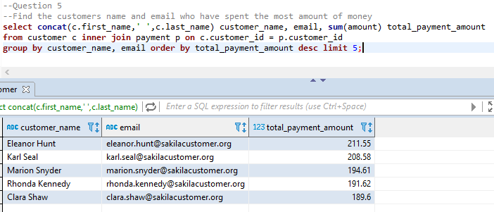

Now, we know that the coupons should send to Eleanor Hunt, Karl Seal, Marion Snyder, Rhonda Kennedy, and Clara Shaw.

**Question 6**

We want to audit our stock of films in all of our store. How many copies of each movie in each store do we have?

The purpose of this question is we need to count the number of film_id group by film_id and store_id that we get from table inventory and join with table film. We also can short the data by film_id by ascending or descending to make it easier to read. The picture below shows the result of this question.

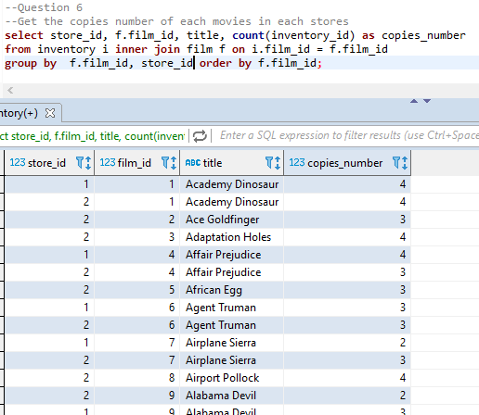

From this query, we get 1521 rows of data

**Question 7**

We want to know what customers are eligible for our platinum credit card. The requirements are that the customer has at least a total of 40 transaction payments. Get the customer name, email who are eligible for the credit card!

The purpose of this question is we need to get customer’s name, email and the count of total transaction for every customer. Then filter the customers who have count of total transaction at least 40 transaction. We can see that this case is aggregation with condition, so we use having to solve the aggregation’s condition. We can get the data from table customer join with table payment. The picture below shows the result of this question.

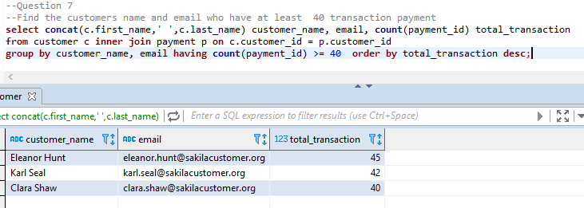

Now, we can give the platinum credit card to Eleanor Hunt, Karl Seal, and Clara Shaw.

Go to this link to check my query code :

<https://github.com/irwanafandi24/IYKRA-Bootcamp>

More specific:

<https://github.com/irwanafandi24/IYKRA-Bootcamp/blob/master/Week%202%20(Coding%20SQL%20Python%20Shell%20Script)/dvd%20rental%20sql%20case.sql>

1. Please make a python function that introduce your name, address, date of birth, and print them out into one sentence!

**Answer:**

To answer this question we need to understand how to build a function in python. So the pattern of the syntax is like this:

***def*** *funct_name (parm1, param2, paramn):*

*operation*

***return*** *variable*

And then to call the function is like this

*var_x =* ***funct_name****(value1, value2, valuen)*

This question asked to make input from keyboard based on the question which has been given. So we can use input method, note: input method always return string value.

*var_x = input(“Question: ”)*

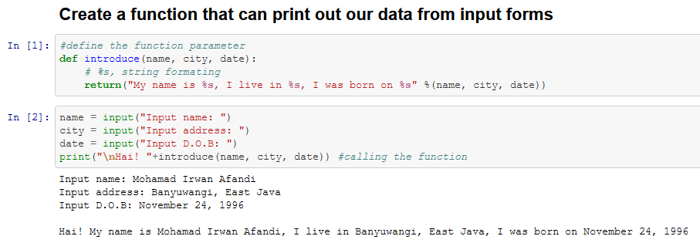This is the result from this task:

Go to this link to check my query code :

<https://github.com/irwanafandi24/IYKRA-Bootcamp>

More specific:

<https://github.com/irwanafandi24/IYKRA-Bootcamp/blob/master/Week%202%20(Coding%20SQL%20Python%20Shell%20Script)/Fuction%20Example.ipynb>

1. Write an article on Medium which explain python and jupyter notebook installation guide!

**Answer:**

This is the medium’s link for jupyter notebook installation post:

<https://medium.com/@mohamadirwanafandi/start-playing-with-python-and-jupyter-notebook-on-windows-10-64-bit-8dea959c920e>

1. Write an article on Medium which covers these subtopics:

a. How to make a file and its content in linux

b. Copy the file, then rename the second file

c. Make a new directory, move the second file into the directory.

d. Then finally remove the first directory.

**Answer:**

This is the medium’s link for the basic linux commands post:

<https://medium.com/@mohamadirwanafandi/introduce-to-linux-commands-5529502c2cf3>

**Conclusion**

There are a lot of way to go to Japan, no matter how. The most important thing is we can arrive in that country then take a selfie with tesla tower in Tokyo. It’s same with the code, there are a lot of algorithm to solve a problem with the code and it depends on how we think. If there is an easier and more efficient way why do we choose an inefficient way? The question is how to get an effective one? *keep practice every day*.